**PRODUCT DEMAND PREDICTION WITH MACHINE LEARNING**

**Phase 2 submission Document**

**PROJECT:Product Demand Prediction**

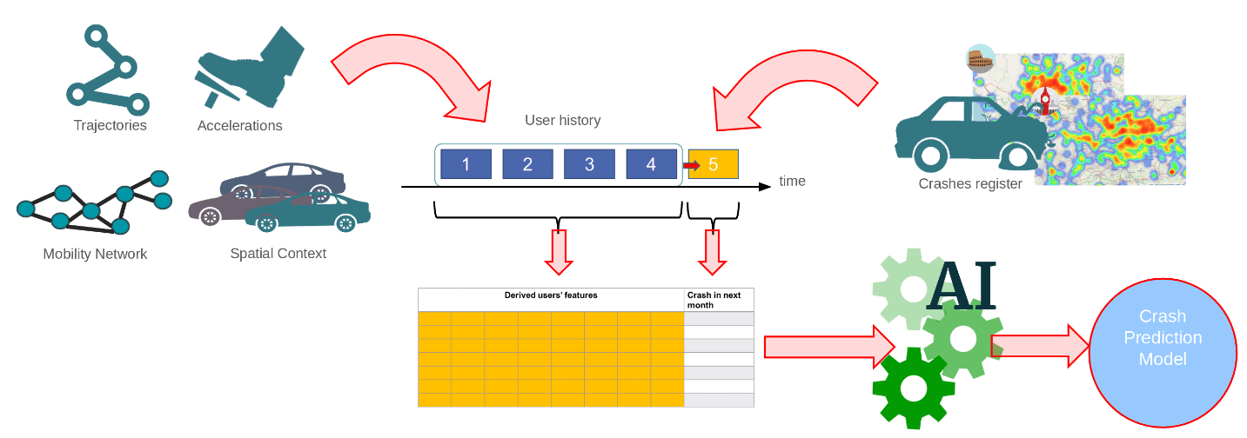

[This Photo](https://www.europeandissemination.eu/trackknow-project/9678) by Unknown Author is licensed under [CC BY-NC-ND](https://creativecommons.org/licenses/by-nc-nd/3.0/)

**Data Integration and Augmentation:** Collect data from a wide range of sources, including social media, weather, economic indicators, and competitor data. Augment your dataset with external variables that could impact demand.

**Time Series Forecasting:** Utilize advanced time series forecasting techniques like ARIMA, Exponential Smoothing, or Prophet to model historical demand patterns.

**Deep Learning:** Employ deep learning models, such as Recurrent Neural Networks (RNNs), Long Short-Term Memory (LSTM) networks, or Transformer models like GPT-3.5, for improved sequence modeling and prediction accuracy.

**Ensemble Learning:** Combine predictions from multiple models, like Random Forests, Gradient Boosting, and neural networks, to create an ensemble model that often outperforms individual models.

**Explainable AI (XAI):** Ensure transparency in your model by using XAI techniques like SHAP (SHapley Additive exPlanations) or LIME (Local Interpretable Model-agnostic Explanations) to explain why a model made a specific prediction. This is crucial for business stakeholders to trust and act upon the model's predictions.

**Real-time Data:** Develop real-time demand prediction systems that continuously update predictions as new data becomes available enabling businesses to respond swiftly to changes in demand.

**Hybrid Models:** Combine statistical time series forecasting models with machine learning models for improved accuracy. For example, use LSTM to capture long-term dependencies and ARIMA to model short-term variations.

**Feature Engineering:** Invest in feature engineering to create meaningful input features for your models. For example, engineer lag features, moving averages, or seasonality indicators.

**IoT Integration:** In industries with IoT devices, consider integrating sensor data to enhance your predictions. This can be especially useful in fields like manufacturing and agriculture.

DATA SOURCE:

**DatasetLink:**[**https://www.kaggle.com/datasets/chakradharmattapalli/product-demand-prediction-with-machine-learning**](https://www.kaggle.com/datasets/chakradharmattapalli/product-demand-prediction-with-machine-learning)

PROGRAM:

import pandas as pd

import numpy as np

import plotly.express as px

import seaborn as sns

import matplotlib.pyplot as plt

from sklearn.model_selection import train_test_split

from sklearn.tree import DecisionTreeRegressor

data = pd.read_csv("https://raw.githubusercontent.com/amankharwal/Website-data/master/demand.csv")

data.head()

OUTPUT:

**ID Store ID Total Price Base Price Units Sold**

**0 1 8091 99.0375 111.8625 20**

**1 2 8091 99.0375 99.0375 28**

**2 3 8091 133.9500 133.9500 19**

**3 4 8091 133.9500 133.9500 44**

**4 5 8091 141.0750 141.0750 52**

fig = px.scatter(data, x="Units Sold", y="Total Price",size='Units Sold')

fig.show()

correlations = data.corr(method='pearson')

plt.figure(figsize=(15, 12))

sns.heatmap(correlations, cmap="coolwarm", annot=True)

plt.show()

OUTPUT:

